Semester One Examination 2017 | 
Question/Answer Booklet
12 ATAR PHYSICS

Student  Number: | In  Figures | 
 | In words
Name

Time allowed for this paper
Reading time before commencing work: Ten minutes
Working time for paper: 180 minutes

Materials required/recommended for this paper

To be provided by the supervisor

This Question/Answer Booklet Formulae and Data Booklet

To be provided by the candidate
Standard items: pens (blue/black preferred), pencils (including coloured), sharpener, correction tape/fluid, eraser, ruler and highlighters
Special items: non-programmable calculators approved for use in the WACE examinations, drawing templates, drawing compass and a protractor

Important note to candidates

No other items may be taken into the examination room. It is your responsibility to ensure that you do not have any unauthorised notes or other items of a non-personal nature in the examination room. If you have any unauthorised material with you, hand it to the supervisor before reading any further.

Structure of this paper
Section | Number of questions available | Number of questions to be answered | Suggested working time (minutes) | Marks available | Percentage of exam
Section One: Short answers | 12 | 12 | 60 | 65 | 36
Section Two: Problem-solving | 5 | 5 | 80 | 75 | 42
Section Three: Comprehension | 14 | 14 | 40 | 40 | 22
 |  |  |  | Total | 100

Instructions to candidates
- Write your answers in this Question/Answer Booklet.
- When calculating numerical answers, show your working or reasoning clearly and neatly. Give final answers to three significant figures and include appropriate units where applicable.
When estimating numerical answers, show your working or reasoning clearly. Give final answers to a maximum of two significant figures and include appropriate units where applicable.
- You must be careful to confine your responses to the specific questions asked and to follow any instructions that are specific to a particular question.
- The Formulae and Data Booklet is available separately and not in the Question/Answer Booklet.

Section One. Short responses. 36% (65 Marks)

Attempt ALL TWELVE (12) questions in this section. Marks for each question are clearly identified.
________________________________________________________________

Question 1 (4 marks)
a) A projectile is thrown with an initial velocity V at an angle of θ.
Which pair of graphs best represents the motion of a projectile? Circle the correct answer. Note that V_{x} is the horizontal component and V_{y} is the vertical component of initial velocity V respectively. Assume negligible air resistance. [2]

Question 1
b) Two long, straight parallel conductors X and Y each have a current of 5.0 A flowing in the same direction as shown below. They are 5.0 cm apart.

In which one of the following situations could conductor X experience the same force per unit length as when it is parallel to conductor Y? Circle the correct answer.
[2]
Question 2 (6 marks)
a) A comet moving towards the Sun is continuously accelerating and therefore gaining a certain form of energy. Explain this phenomenon using physics principles. [3]

b) The weight exerted by an 85 kg mass when it is 8.00 x 10³ km away from the centre of a planet is 4.25 x 10² N. Calculate the mass of this planet. [3]

Question 3 (5 marks)
Calculate the tension in both ropes from which a 10 kg mass is supported.
One rope is making 50º to the horizontal ceiling and the rope is at an angle of 70º to the vertical wall (shown in diagram below).

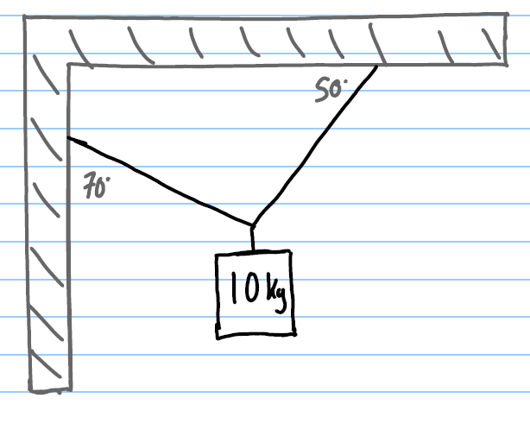

Question 4 (4 marks)
A cable is attached 2/3 of the way up from the pivot supporting a 250 kg uniform boom as shown right. The cable is perpendicular to the boom.

The boom is balanced at an angle of 55º to the horizontal.
What is the tension T in the cable?
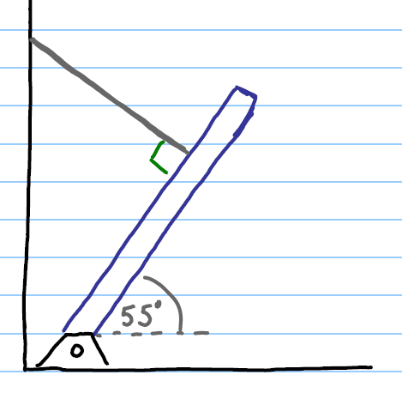
T

Question 5 (7 marks)
A satellite travels around a planet at 6.5 x 10³ m/s with an orbital radius of 1.1 x 10⁷ m.

a) Determine the mass of the planet? [4]

b) What is the speed of an identical satellite traveling at half the orbital radius? [3]

Question 6 (5 marks)
a) A 1400 kg car rounds a flat circular corner of radius 95 m. If the friction between the tires and the road is 7546 N, what is the maximum speed that the car can travel? [3]

This is a top view of the car in the previous question which is traveling in
a counter clockwise circle.

b) Draw and label clearly the direction of velocity and acceleration of the car at this point. [2]

Question 7 (9 marks)
An electric lawnmower uses 130 W of power. The gardener drew the heights of different grass shown below in his notebook. When cutting medium height grass, the battery has an EMF of 15 V and the resistance of the motor is 1.2 Ω.
Determine
a) the initial current drawn by the motor? [2]

b) the back EMF generated while cutting the grass [3]

If the lawnmower runs into a patch of tall thick grass what will happen to the
c) the current drawn by the motor? Explain. [2]

d) the back EMF generated? Justify with your response to part c). [2]

Question 8 (2 marks)
Two identical magnets are fixed in a position on a flat bench. A compass is placed near the magnets.
COMPASS

a) Sketch the magnetic field in the region around the magnets. [1]

b) Indicate the direction that the compass will point by placing an arrow in the circle. [1]

Question 9
The magnetic field due to a current in a straight wire is determined by the following equation.

Given that the permeability of free space µ₀ is a constant = 4 π x 10⁻⁷ T m A⁻¹ and r being the perpendicular distance from the wire.

Question 9 (continued) (6 marks)
Two parallel straight wires A and B are 10.0 cm apart carry currents in opposite directions. Current in wire A is 5.0 A out of the page and current in wire B is 7.0 A into the page.

a) Draw a diagram below to represent the situation. [2]

b) Determine the magnitude and direction of the resultant magnetic field halfway between the wires. [4]

Question 10 (8 marks)
A pivoted solid metal bar A falls at speed v ms⁻¹ through a magnetic field.
It is now replaced with a pivoted solid metal bar B with slots and now falls at speed d ms⁻¹ through the same magnetic field shown below.

a) Which metal bar drops more quickly? ________________ [1]
b) Justify your answer. [3]

c) In an induction stove shown below, an alternating current pass around a coil that is the “burner” (a burner that never gets hot). Why will it heat a metal pan but not a glass container? Justify with physics principles and equations. [4]

Question 11 (4 marks)
Jieber did experiments (A) and (B) on electromagnetic induction.
a) Describe what Jieber could have done to explain the physics phenomenon shown in each diagram. State clearly the pole induced in the coil viewed from the bottom view of Jieber’s hand.

A B

Question 12 (5 marks)
The Earth’s magnetic field lines are shown below.
a) At what location, poles or equator is the magnetic field strength the greatest? Justify. [2]

A power line carries a 225 A current from East to West, parallel to the surface of Earth.
b) Calculate the magnetic force resulting from the Earth’s magnetic field of 50 µT acting on each meter of the wire? [2]

c) In your judgement, would this force be important in designing towers to hold this power line? Explain. [1]

[Total: 65 marks]
ANSWERS
1(a) C
1(b) D

2a) The Sun exerts gravitational force on the comet continuously. Force causes acceleration according to F = ma, and acceleration causes an increase in the speed v of the comet. Kinetic energy = ½ mv², so the comet’s KE increases.

2b) 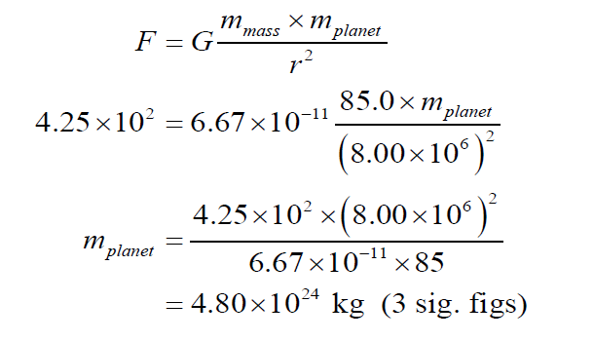
3)
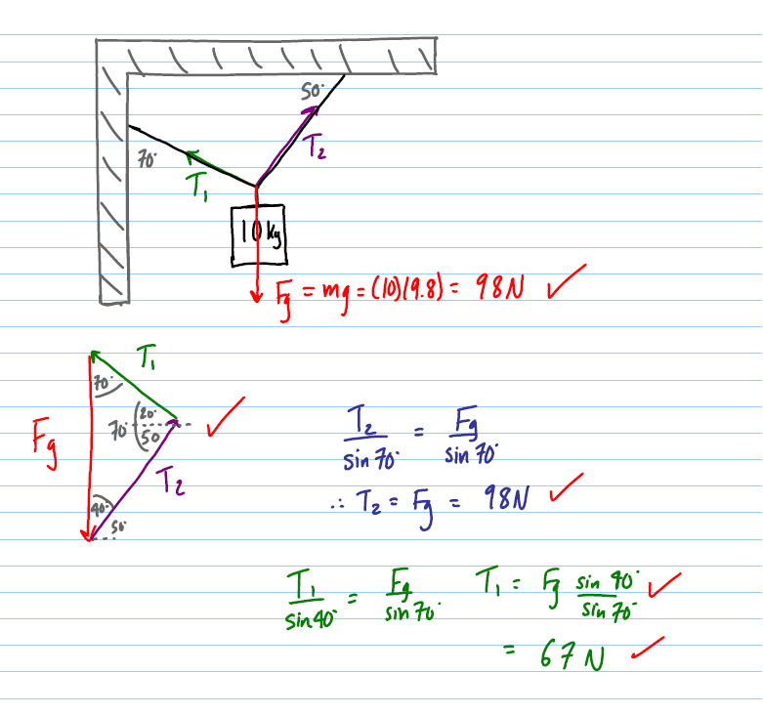

4)
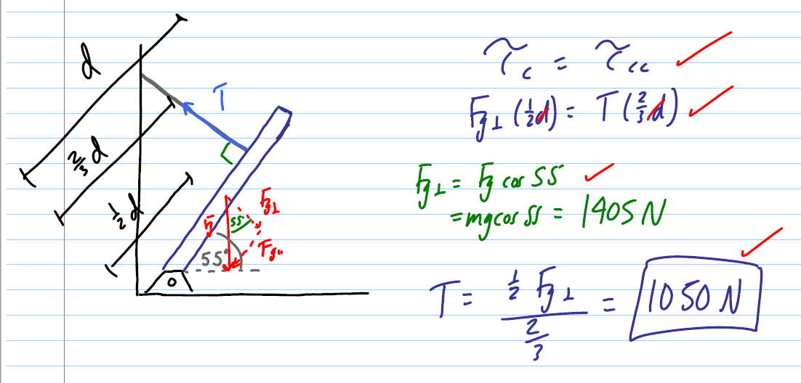
5)
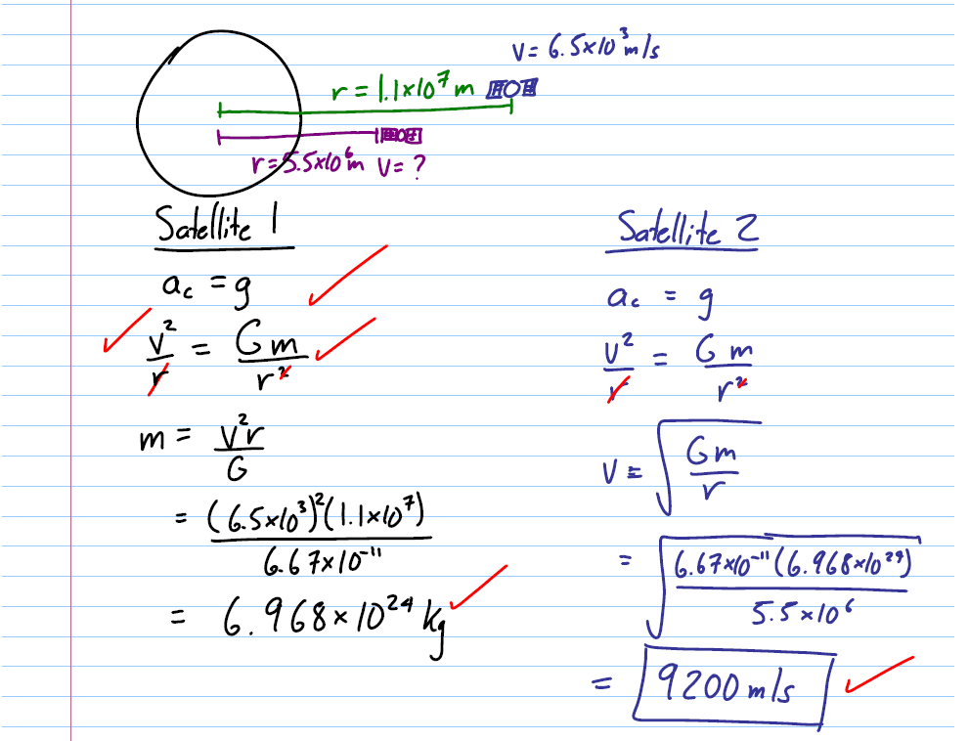

6a)
6(b)

7a)

7b)
7c)

7d)

8a) & b)
9a)
9b)

10a) B (metal bar with slots)
10b)
10c)

11(a)
For (A),
a current is induced (inducing SOUTH pole in coil seen from bottom view)
when Jieber moves the magnet AWAY from the coil, momentarily DECREASING the MAGNETIC FLUX linking to the coil.

For (B),
No current is induced. Jieber has held the magnet stationary
No change in magnetic flux linkage due to no relative motion between coil and magnet.

12a)
12b)
12c)

